**DAY1 – ADVANCED TRAINING**

**Generic Class :**

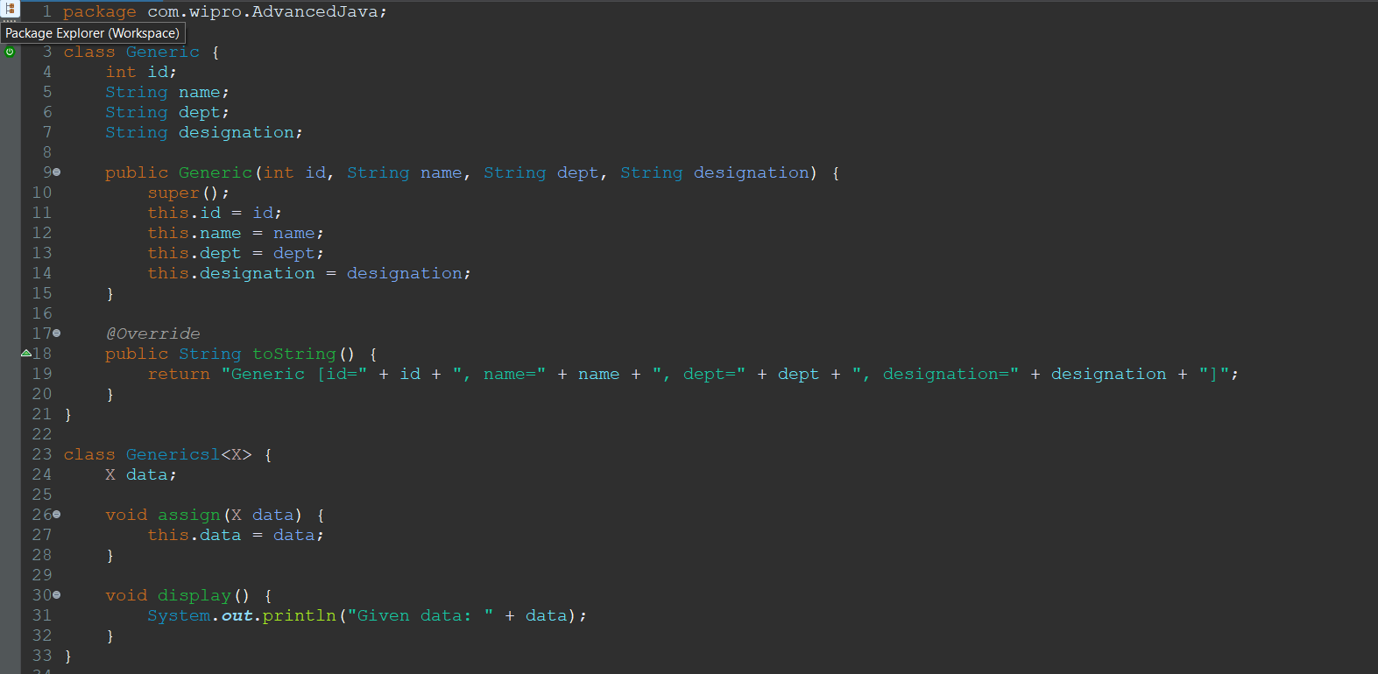

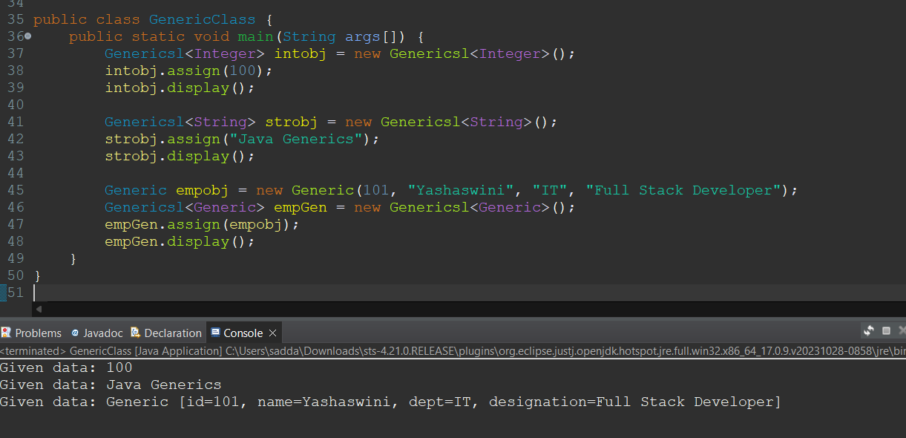

**Generic Methods :**

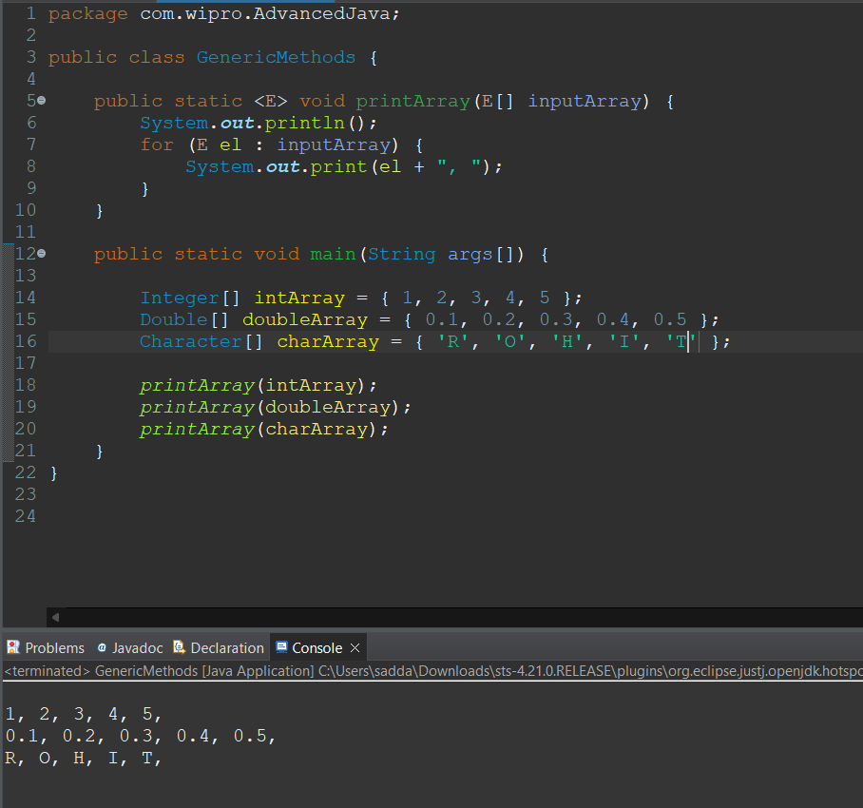

**Reflection – Class information**

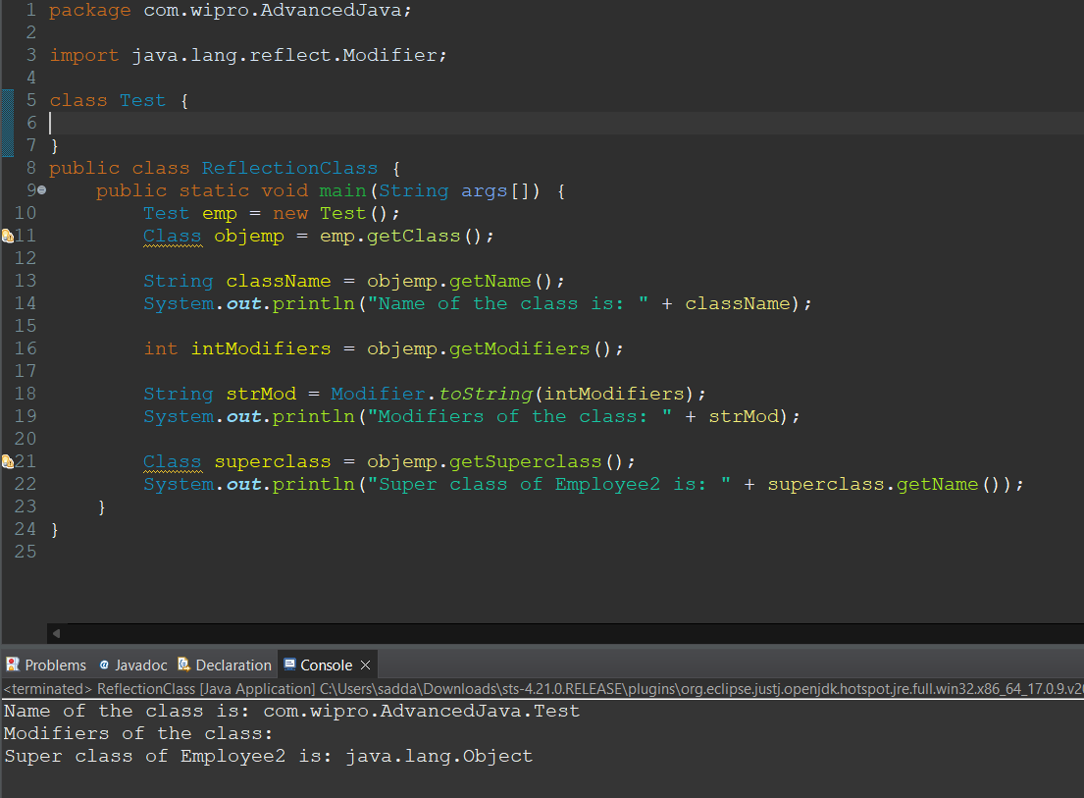

**Reflection – Method Information**

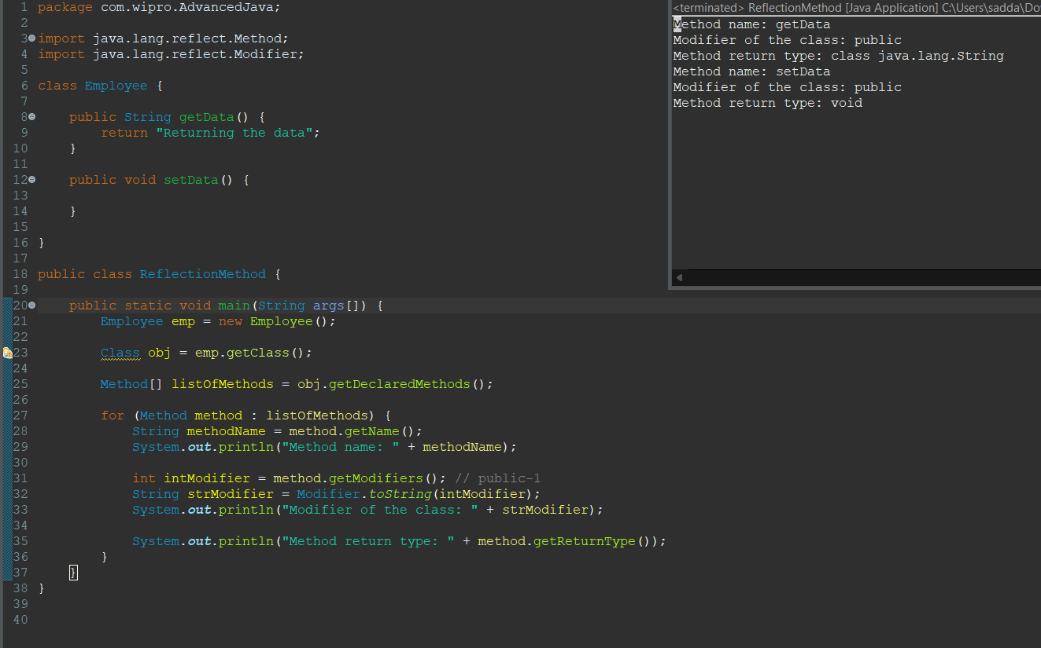

**Reflection – Accessing Private Attribute**

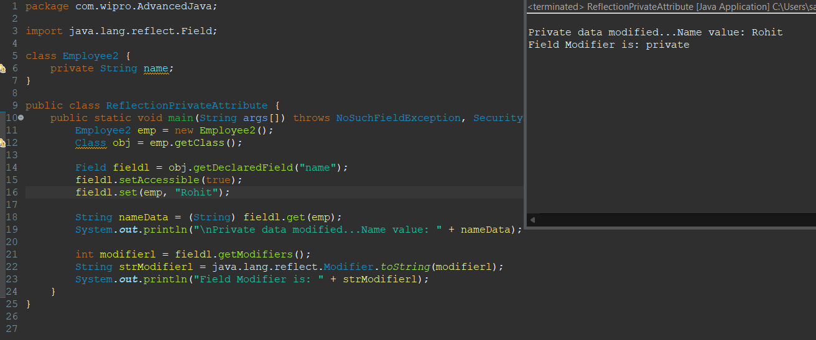

**Lambda Expression**

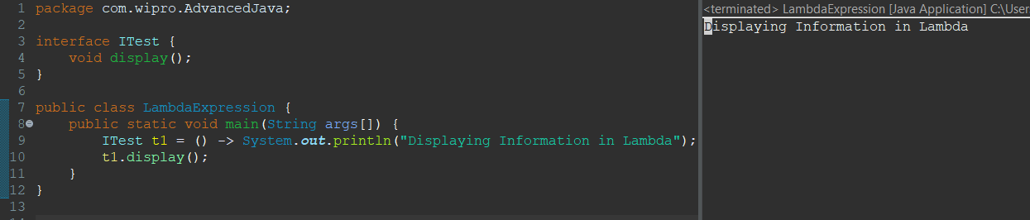

**Lambda with arguments**

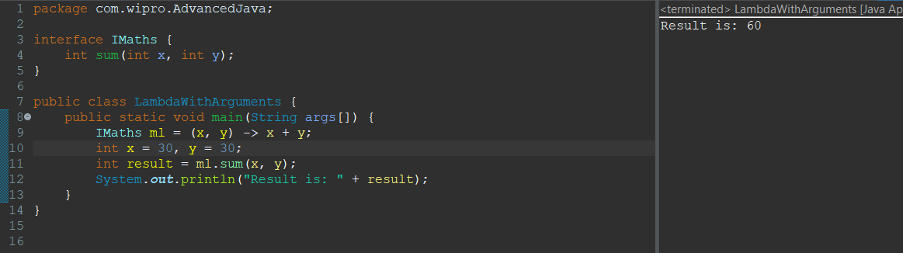

**Predicate**

